. Data analysis and statistical language R. Week 2
As you know, art is a reflection of the real world. There is a perception that our world is becoming more violent. Let's look at this issue through the prism of contemporary cinema. The criterion of rigidity of the film will use the number of characters in it are killed. The criterion popularity rating IMDB http://www.imdb.com/help/show_leaf?votestopfaq.

Data taken from the resource Movie Body Counts http://www.moviebodycounts.com/. This is a forum where users indicate How much characters were killed in this film. The dataset has 545 films from 1949 to 2013. Killed considered characters (humans, monsters, zombies, aliens), whose body is displayed on the screen. If this crowd scenes - like the explosion of the Death Star, these characters are not counted.
Dataset collected Randy Olson https://figshare.com/articles/On_screen_movie_kill_counts_for_hun dreds_of_films/889719
We use the library:
• dplyr: cleaning and data transformation
• ggplot2: data visualization
Load the library:
library (dplyr)
library (ggplot2)
Load the file:
movie_body_counts <- read.csv ( 'filmdeathcounts.csv')
Explore the structure of our datasetu:
head(movie_body_counts)

## |  | Film | Year Body_Count MPAA_Rating
## 1 24 Hour Party People 2002 |  |  |  | 7 |  | R
## 2 |  | 28 Days Later 2002 |  | 53 |  | R
## 3 |  | 28 Weeks Later 2007 |  | 212 |  | R
## 4 |  | 30 Days of Night 2007 |  | 67 |  | R
## 5 |  | 300 | 2007 | 600 |  | R
## 6 |  | 3:10 To Yuma 2007 |  | 45 |  | R
## | Genre |  |  |  | Director Length_Minutes
## 1 | Biography|Comedy|Drama|Music |  |  |  | Michael Winterbottom |  |  | 117
## 2 | Horror|Sci-Fi|Thriller |  |  |  | Danny Boyle |  |  | 113
## 3 | Horror|Sci-Fi|Thriller Juan Carlos Fresnadillo |  |  |  |  |  |  | 100
## 4 | Horror|Thriller |  |  |  | David Slade |  |  | 113
## 5 | Action|Fantasy|History|War |  |  |  | Zack Snyder |  |  | 117
## 6 Adventure|Crime|Drama|Western |  |  |  |  | James Mangold |  |  | 122
## | IMDB_Rating
## 1 | 7.3
## 2 | 7.6
## 3 | 7.0
## 4 | 6.6
## 5 | 7.7
## 6 | 7.8

 | str(movie_body_counts)
## 'data.frame': |  |  |  | 545 obs. of |  |  | 8 variables:
## |  | $ Film |  | : Factor w/ |  |  | 537 levels "24 Hour Party People",..: 1 2 3 5
6 4 |  | 7 8 | 9 10 ...
## |  | $ Year |  | : int |  | 2002 | 2002 2007 2007 2007 2007 1999 1986 1987 1977
...
## |  | $ Body_Count |  | : int |  | 7 53 | 212 67 600 45 1 65 199 243 ...

## | $ MPAA_Rating |  |  | : Factor |  | w/ 10 |  | levels "Approved","G",..: 8 8 8 8 8 8 8 8
8 6 ...
## | $ Genre |  |  | : Factor |  | w/ 208 |  | levels "Action|Adventure",..: 136 199 199
200 | 88 | 115 166 | 62 | 62 178 ...
## | $ Director |  |  | : Factor |  | w/ 330 |  | levels "Aaron Norris",..: 213 49 168 62 3
30 | 129 | 143 158 | 158 248 ...
## | $ Length_Minutes: int |  |  |  | 117 |  | 113 | 100 113 117 122 123 95 105 175 ...
## | $ IMDB_Rating |  |  | : num | 7.3 |  | 7.6 | 7 6.6 7.7 7.8 6.4 7.5 7.3 7.4 ...

Add a new field body_per_min, which contains the ratio of those killed in the movie to the length of the movie in minutes:
movie_body_counts$body_per_min <- movie_body_counts$Body_Cou nt/movie_body_counts$Length_Minutes

Construct a histogram for the number of characters who have died:

ggplot(movie_body_counts, aes(x=Body_Count)) + geom_histogram(bins=20, color="grey", fill="lightblue")
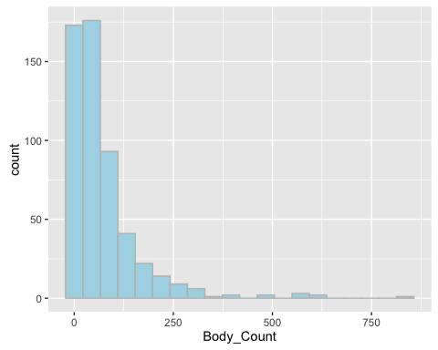
Find the top 10 films, killing most of the characters:
movie_body_counts %>%

top_n(n = 10, Body_Count) %>% arrange(desc(Body_Count))

## | Film Year Body_Count MPAA_Rating
## 1 | Lord of the Rings: Return of the King 2003 |  | 836 | PG-13
## 2 | Kingdom of Heaven 2005 |  | 610 | R
## 3 | 300 | 2007 | 600 | R
## 4 | Tae Guk Gi: The Brotherhood of War 2004 |  | 590 | R
## 5 | Troy 2004 |  | 572 | R
## 6 | The Last Samurai 2003 |  | 558 | R
## 7 | A Fistful of Dynamite 1971 |  | 471 | PG
## 8 | Lord of the Rings: Two Towers 2002 |  | 468 | PG-13
## 9 | Windtalkers 2002 |  | 389 | R
## 10 | King Arthur 2004 |  | 378 | R

## | Genre | Director Length_Minutes
## 1 | Action|Adventure|Fantasy | Peter Jackson | 201
## 2 | Action|Adventure|Drama|History|War | Ridley Scott | 144
## 3 | Action|Fantasy|History|War | Zack Snyder | 117
## 4 | Action|Drama|War | Je-kyu Kang | 140
## 5 | Adventure|Drama Wolfgang Petersen |  | 163
## 6 | Action|Drama|History|War | Edward Zwick | 154
## 7 | Adventure|Western | Sergio Leone | 138
## 8 | Action|Adventure|Fantasy | Peter Jackson | 179
## 9 | Action|Drama|War | John Woo | 134
## 10 | Action|Adventure|Drama | Antoine Fuqua | 126
- IMDB_Rating body_per_min

## 1 | 8.9 | 4.159204
## 2 | 7.1 | 4.236111
## 3 | 7.7 | 5.128205
## 4 | 8.1 | 4.214286
## 5 | 7.1 | 3.509202
## 6 | 7.7 | 3.623377
## 7 | 7.7 | 3.413043
## 8 | 8.7 | 2.614525
## 9 | 5.9 | 2.902985
## 10 | 6.2 | 3.000000

And movies, killing the largest number of characters in relation to the length of the film:

movie_body_counts %>%

top_n(n = 10, body_per_min) %>% arrange(desc(body_per_min))

## | Film | Year Body_Count MPAA_Rating
## 1 | 300 | 2007 | 600 | R
## 2 | Kingdom of Heaven | 2005 | 610 | R
## 3 | Tae Guk Gi: The Brotherhood of War 2004 |  | 590 | R
## 4 | Lord of the Rings: Return of the King | 2003 | 836 | PG-13
## 5 | The Last Samurai | 2003 | 558 | R
## 6 | Troy | 2004 | 572 | R
## 7 | A Fistful of Dynamite | 1971 | 471 | PG
## 8 | King Arthur | 2004 | 378 | R
## 9 | The Big Red One | 1980 | 338 | R
## 10 | Windtalkers 2002 |  | 389 | R
## | Genre |  | Director Length_Minutes
## 1 | Action|Fantasy|History|War | Zack Snyder |  | 117
## 2 | Action|Adventure|Drama|History|War | Ridley Scott |  | 144
## 3 | Action|Drama|War | Je-kyu Kang |  | 140
## 4 | Action|Adventure|Fantasy | Peter Jackson |  | 201
## 5 | Action|Drama|History|War | Edward Zwick |  | 154
## 6 | Adventure|Drama Wolfgang Petersen |  |  | 163
## 7 | Adventure|Western | Sergio Leone |  | 138
## 8 | Action|Adventure|Drama | Antoine Fuqua |  | 126
## 9 | Action|Drama|War | Samuel Fuller |  | 113
## 10 | Action|Drama|War |  | John Woo | 134

- IMDB_Rating body_per_min
## 1 | 7.7 | 5.128205
## 2 | 7.1 | 4.236111
## 3 | 8.1 | 4.214286
## 4 | 8.9 | 4.159204
## 5 | 7.7 | 3.623377
## 6 | 7.1 | 3.509202
## 7 | 7.7 | 3.413043
## 8 | 6.2 | 3.000000
## 9 | 7.3 | 2.991150
## 10 | 5.9 | 2.902985

Construct a histogram IMDB rating:

ggplot(movie_body_counts, aes(x=IMDB_Rating)) + geom_histogram(bins=10, color="grey", fill="lightblue")
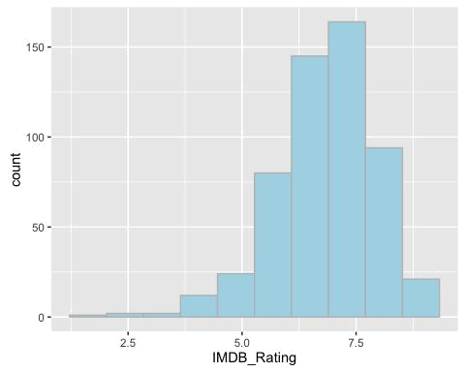

Find the mean and standard deviation for the variable IMDBrating, variables and give names imdb_mean
imdb_sd:
imdb_mean <- your code here imdb_sd <- your code here
Let's generate a normal distribution that has a mean value and standard deviation imdb_mean imdb_sd. To use this feature rnorm. To sequence was generated constant at each performance of our code, set set.seed
set.seed(900)

imdb_simulation <- rnorm(n=nrow(movie_body_counts), mean = i mdb_mean, sd = imdb_sd)

Add these values to our table:
movie_body_counts$imdb_simulation <- imdb_simulation

imdb_simulation:

Construct a histogram for the simulation:

ggplot(movie_body_counts, aes(x=imdb_simulation)) + geom_histogram(bins=10, color="grey", fill="lightblue")
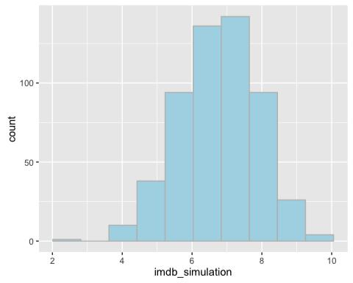

To test whether the normal distribution, use function qqplot. Let's use it to check whether the normally distributed data rating IMDB. First
qqplot build our simulation

ggplot(movie_body_counts, aes(sample = imdb_simulation)) + stat_qq()
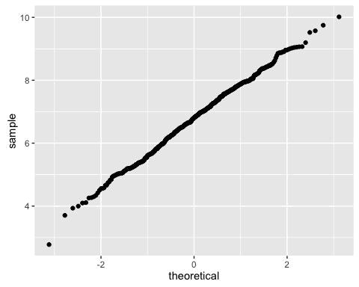

And now for the real rating IMDB_Rating:

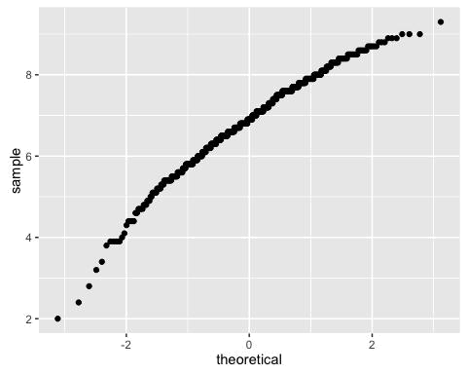
ggplot(movie_body_counts, aes(sample = IMDB_Rating)) + stat_ qq()

